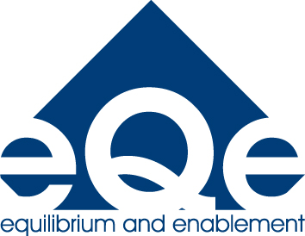


Think it,
Feel it,
Be it.

Using the theory of CBT to increase understanding of behaviour

This course will introduce the basic theory of Cognitive Behavioural Therapy and use it to increase your understanding of human behaviour. The course will be experiential and will use creative approaches, introducing approaches and strategies for working with children and young people to change their behaviour.

Cath Mackay is a qualified social worker who has worked in Probation and Youth Justice, and for the NSPCC delivering therapeutic interventions for children and families. She has also specialised in sexual abuse assessment and intervention. She is currently a mental health practitioner with a community based CAMHS team, which focuses on Looked after Children and Children in Need. She is also a qualified Cognitive Behavioural Therapist who also works for Adult Mental Health.

Date TBC
9.30-3.30
eQe Training Centre
(attached to Abbey Hey Primary School )
Cost: £80+VAT (includes lunch)

Understanding Behaviour and Emotional Needs

Suitable for all school staff and family workers

